Content Consumption Patterns in the Entertainment Sector

Pooja Joshi & E.Code [E25007]

# Overview

The entertainment sector encompasses a vast range of media and content that caters to diverse audience segments. Audience segmentation analysis is essential in understanding the consumption patterns of different groups, enabling more targeted content delivery and marketing efforts. This analysis helps in identifying distinct segments based on shared characteristics, behaviors, or needs, allowing businesses to personalize their strategies to improve engagement, satisfaction, and revenue.

# Objective

To perform audience segmentation analysis in the entertainment sector, aiming to categorize viewers into distinct groups based on their demographics, behaviors, and preferences. This process will enhance the effectiveness of marketing strategies and content recommendations by providing tailored messaging and offerings that resonate with specific audience segments.

# Assigned Task(s)

Data Preparation:

   - Handle missing values and ensure the dataset is cleaned.

   - Standardize categorical variables and format date columns.

Exploratory Data Analysis (EDA):

   - Generate visualizations to explore patterns in popularity, vote counts, and ratings.

   - Analyze trends over time (e.g., release year).

Content Consumption by Category:

   - Perform analysis based on language and potentially genre.

Correlation and Segmentation:

   - Investigate correlations between key metrics.

# Task Details

**Task 1: Data Preparation**

  Status: Completed

  Details: Missing values were handled by filling numerical columns with median values. Categorical values (e.g., `original_language`) were standardized, and `release_date` was converted to a valid date time format.

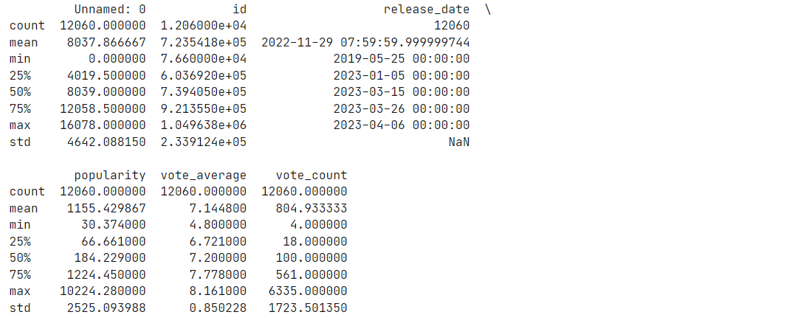

**Task 2: Exploratory Data Analysis (EDA)**

Status: Completed

Details: We explored trends in content consumption patterns using metrics such as popularity and vote counts over time. Visualizations, including line plots and bar charts, were used to represent the data. The focus was on understanding how content popularity changes over time and which languages have the highest consumption rates.

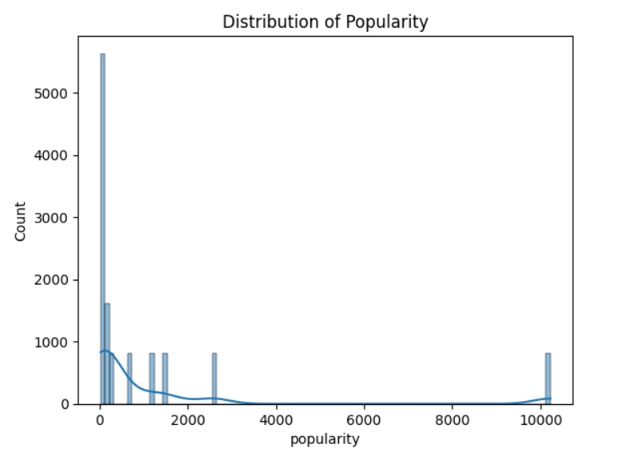

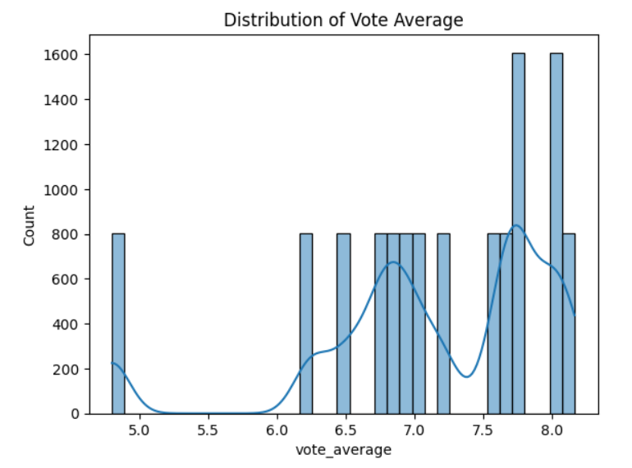

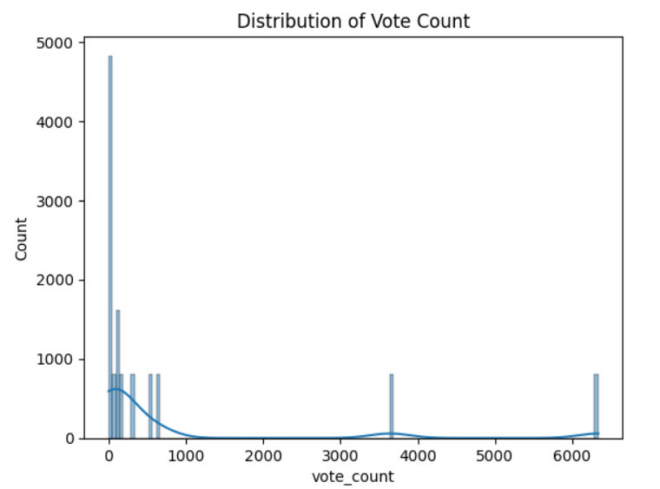

**Task 3: Consumption by Category (Language)**

Status: Completed

Details: The dataset was grouped by the `original_language` column to analyze popularity and vote counts by language. Bar charts were generated to show which languages had the highest average popularity and total vote counts.

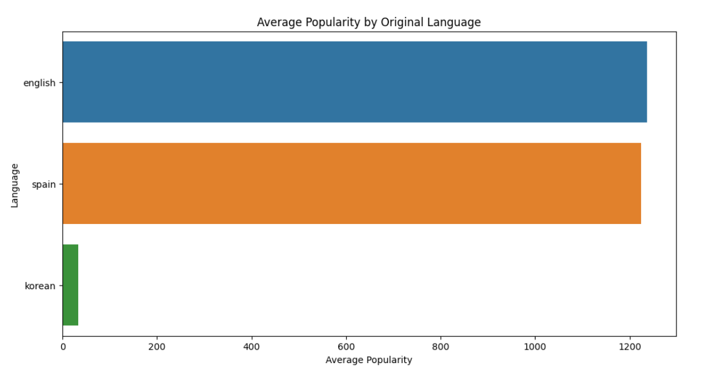

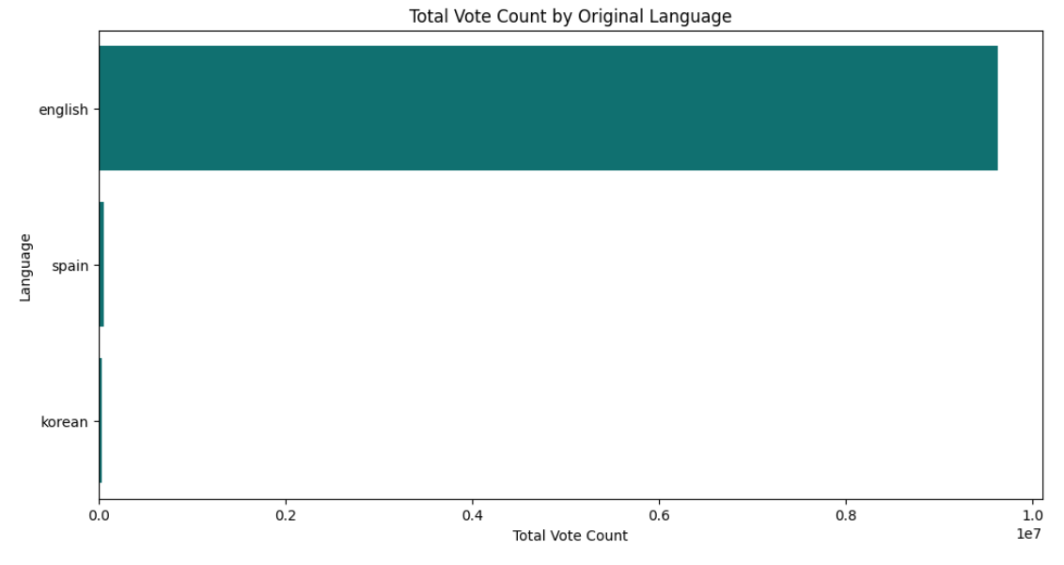

Task 4: Correlation and Segmentation

Status: In Progress

Details: Correlation analysis was conducted to investigate the relationships between popularity, vote counts, and ratings. Audience segmentation based on key engagement factors (e.g., popularity and votes) is ongoing, with preliminary results indicating clear clusters of audience preferences.

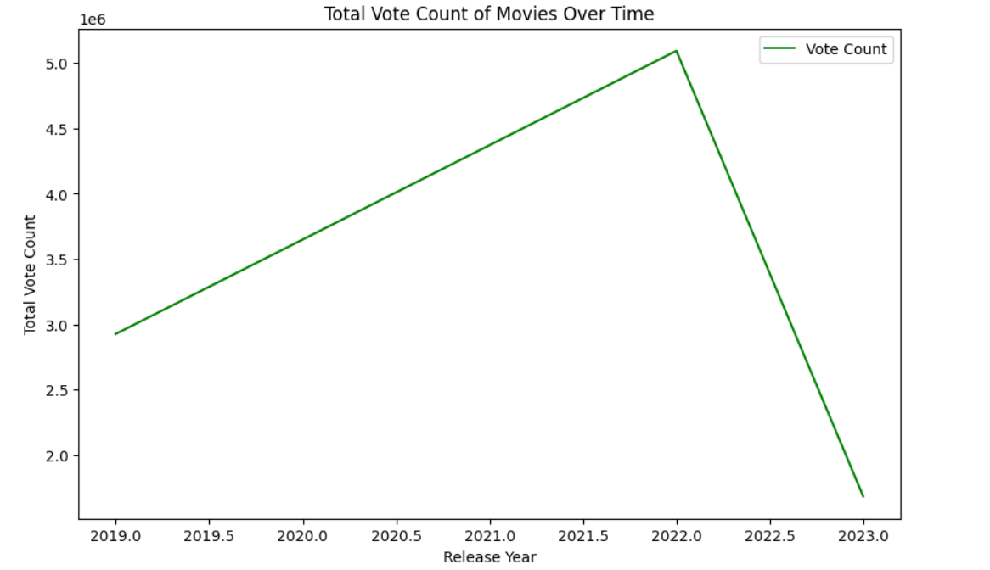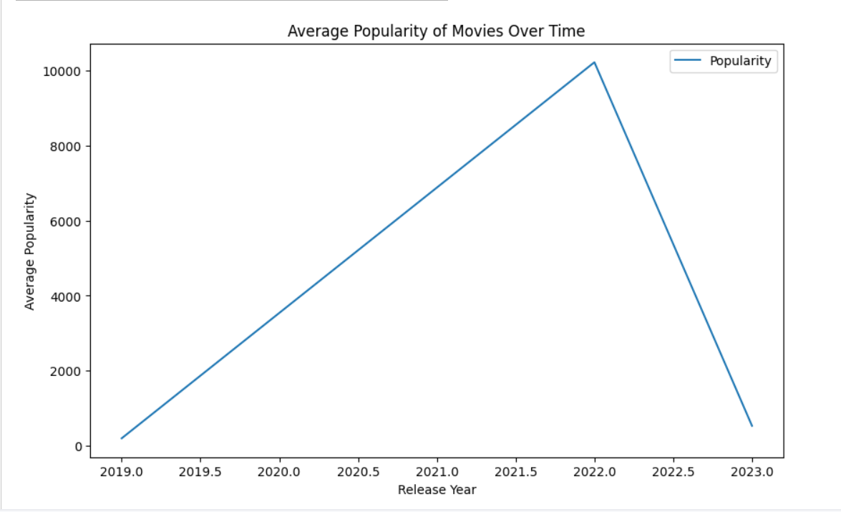

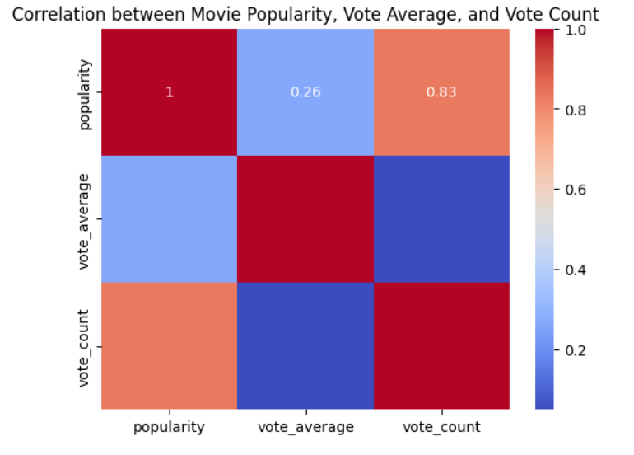

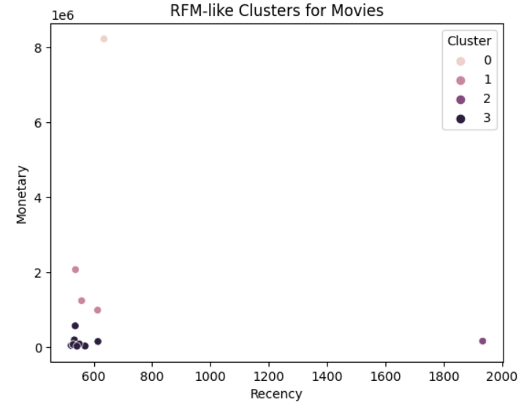

# Progress

Accomplishments :

   - Completed the initial data preparation and cleaning process.

   - Generated key visualizations showing trends in content consumption over time.

   - Identified key insights into language-based content consumption patterns.

Metrics:

   - Movies in English had the highest total vote counts, indicating broader engagement from an international audience.

   - Popularity over time revealed peaks in recent years, likely due to global streaming services and increased digital consumption.

# Challenges and Solutions

**Challenges Faced:**

* The dataset lacked certain demographic details, such as age or region, which would have allowed for deeper audience segmentation.
* Some date fields were invalid, which required careful handling to avoid data loss.

**Solutions Implemented:**

* Missing values were filled using appropriate statistical methods (e.g., median for numerical columns).
* Invalid dates were dropped from the dataset after ensuring that their exclusion would not significantly affect the analysis.

# Next Steps

 Finalize audience segmentation using clustering techniques like K-means.

   - Investigate genre-based analysis if genre data becomes available.

**Goals:**

   - Provide deeper insights into how audience preferences vary based on genre, and enhance the segmentation analysis with potential demographic data.

# Conclusion

* In conclusion, the analysis of content consumption patterns in the entertainment sector has provided valuable insights into how popularity, ratings, and language influence audience engagement. The next steps will focus on finalizing the audience segmentation and exploring potential genre-based patterns to provide even more actionable insights.
* Acknowledgments: Thank you for your time and attention.

# Instructions:

1. Use Google Docs. Single Column
2. TNR stands for Times New Roman: B - Bold
3. Use images as required with proper references
4. Use charts, tables as per your requirement.
5. Number of Pages: 2 to 8 for each task report.